Exercise - 1
1) Create a function that returns summary information about given Series No and Episode No. For example, you should be able to run this command:
SELECT * FROM tblEpisode(1,2)
>Use following schema:

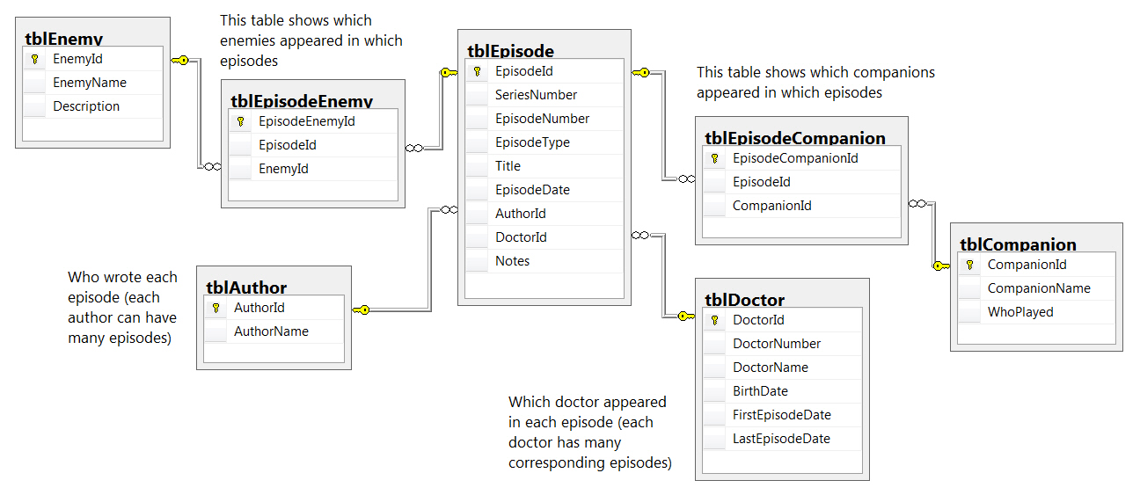

2) Show the number of episodes whose title contain the words “on” and “ol”
Using CTE
> Use the schema of Exercise 1 problem 1.

3) Create a stored procedure, which will output a comma-delimited list of the Doctors who have done 15 or more episodes.
> Use the schema of Exercise 1 problem 1.

4)
- Generate a new column called NumberEnemies(DataType = INT) in the tblEpisode table

- Write an update query which will set NumberEnemies column to equal the number of enemies for each episode (but within a transaction), then: Roll back this transaction if more than 100 rows are affected (displaying a suitable message, as shown below); or Commit it otherwise and show a list of all of the episodes, including the newly populated field.

When you run this query, you should see something like this:
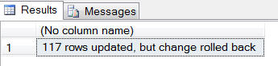

Now change the threshold in the query from 100 to 120 and re-run it. This time the query should update the column, and display the results:
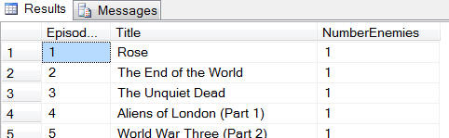

> Use the schema of Exercise 1 problem 1.

Exercise - 2
1) Given the schema Presented below, Find out the sum of amount and cumulative sum for each day.
Table Payment
Column | Type | Modifiers
Payment_date | Date | Not Null
Amount | INT | Not Null

Desired Output:
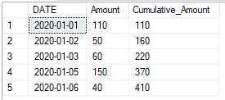

Exercise - 3
1)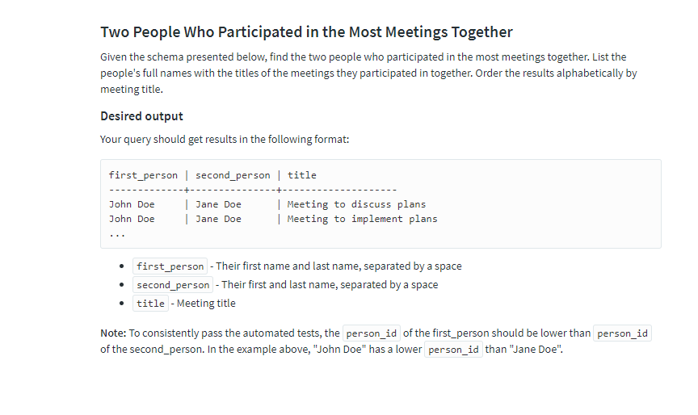

Please the SQL code should produce the results below
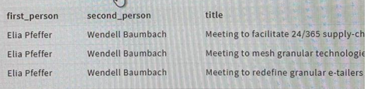
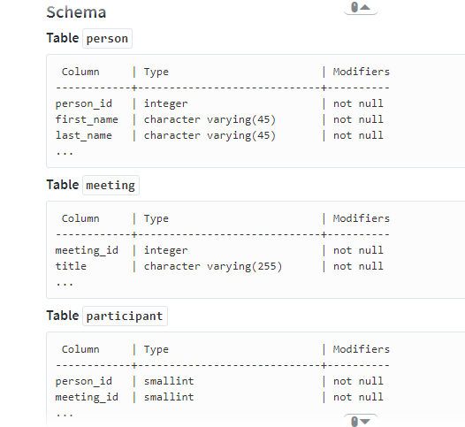
Exercise- 4
1)
You are given two tables.
1.Person
2.Friend
You have to output a table containing PersonID, Name, number of friends, sum of marks of all friends of those individuals who have friends with total score greater than 100.The table should be sorted in increasing order of PersonID. All pairs in Friend table (PersonID, FriendID) are distinct.

Input Format:
Table: Person
Field | Type
PersonID | integer
Name | string
Email | string
Score | integer
Table : Friend
Field | Type
PersonID | integer
FriendID | integer

Output Format:
Field | Type
PersonID | integer
Name | string
number_of_friends | integer
sum_of_scores | integer

Sample Input:
Sample Person Table
PersonID | Name | Email | Score
1 | Alice | alice2018@hotmail.com | 88
2 | Bob | bob2018@hotmail.com | 11
3 | Davis | davis2018@hotmail.com | 27
4 | Tara | tara2018@hotmail.com | 45
5 | John | john2018@hotmail.com | 63
Sample Friend Table
PersonID | FriendID
1 | 2
1 | 3
2 | 1
2 | 3
3 | 5
4 | 2
4 | 3
4 | 5

Sample Output:
PersonID | Name | number_of_friends | sum_of_scores
2 | Bob | 2 | 115
4 | Tara | 3 | 101
Explaination
Person with PersonID 2 has friends with total score 115(Alice 88,Davis 27) which is greater than 100.Similarly, Tara with PersonID 4 has 3 friends with total score greater than 100.All rows are ordered in increasing order of PersonID.

2)
ABC company allows random people to enter in their premises and use the resources. People have to enter their details in the logging system, in order to enter in the company. According to the log one person can enter in the company only once, and it consider two people different if they have different email ids.
You have the table Entries, which stores the information of the logging system.
Entries table comprise the following information of the logging system.
Table :Entries
Field | Type
Name | string
Address | string
Email | string
Floor | int
Resources | string
People being greedy, use different email ids to take entry more than once, but they keep their Name and Address same every time.
For each person, you have to find:
Field | Type
Name | string
Number of Entries | int
Floor | int
Resources | string
Data Assumptions:
1) No two people will be having the same name with different addresses.
2) There will always be a unique floor, to which the person will visit maximum number of times.
For each person, you have to output the unique resources name separated by a comma.
You have to output the required information, in the increasing order of the people names.

Sample Input:
Sample Entries Table:
Name | Address | Email | Floor | Resources
A | Bangalore | A@gmail.com | 1 | cpu
A | Bangalore | A1@gmail.com | 1 | cpu
A | Bangalore | A2@gmail.com | 2 | desktop
B | Bangalore | B@gmail.com | 2 | desktop
B | Bangalore | B1@gmail.com | 2 | desktop
B | Bangalore | B2@gmail.com | 1 | monitor

Sample Output:
Name | Number of Entries | Floor | Resources
A | 3 | 1 | cpu, desktop
B | 3 | 2 | desktop, monitor

3)
Once in a forest, animals tried to decide the strongest animals of the forest in a unique way.
There are two special things about this forest.
1) There are different zones and an animal can belong to multiple zones.
2) Each animal has its own strength.
All the animals are divided into groups. Groups will be formed according to the following criteria:
1) Animals will be considered in the same group, if their set of zones are same.
(Note: Set of zones of one animal is the list of zones to which he belongs)
2) Any alone animal will be in its own group.
The strength of the groups formed is the sum of the strengths of the animals in that group.
The group having maximum strength will consists of the strongest animals of the forest.
You need to print the names of the strongest animals of the forest, separated by a comma and in the ascending order of their names.
Data Information
You will be given 2 tables.
1) Animals
Table: Animals
Field | Type
ID | Integer
Name | Text
Strength | Integer

2) Details
Input Format:
Table: Details
Field | Type
ID | Integer
Zone | Text

Sample Input:
Sample Animals Table:
ID | Name | Strength
1 | Alice | 20
2 | Bob | 30
3 | Alex | 45
Sample Details Table:
ID | Zone
1 | Z1
1 | Z2
2 | Z1
2 | Z2
3 | Z1
3 | Z2
3 | Z3

Sample Output:
Names
Alice,Bob

Explaination
Here Animals with ID 1 and 2 have same set i.e {Z1, Z2}, while animal with ID 3 have set which is {Z1,Z2,Z3}.
So 2 groups will be formed, where one group (say Group A) will have animals with ID 1 and 2 and another group (say Group B) will have animal with ID 3.
It implies, Group A will have total strength as 50 and Group B will have total strength as 45.
So the animals who belongs to Group A are the strongest animals in the forest and animal with ID 1 is Alice and with ID 2 is Bob. So the answer is:
|Alice, Bob|

4) Using the Source and Target table, write a query to arrive at the Output table as shown in below image. Provide the solution without using subqueries..
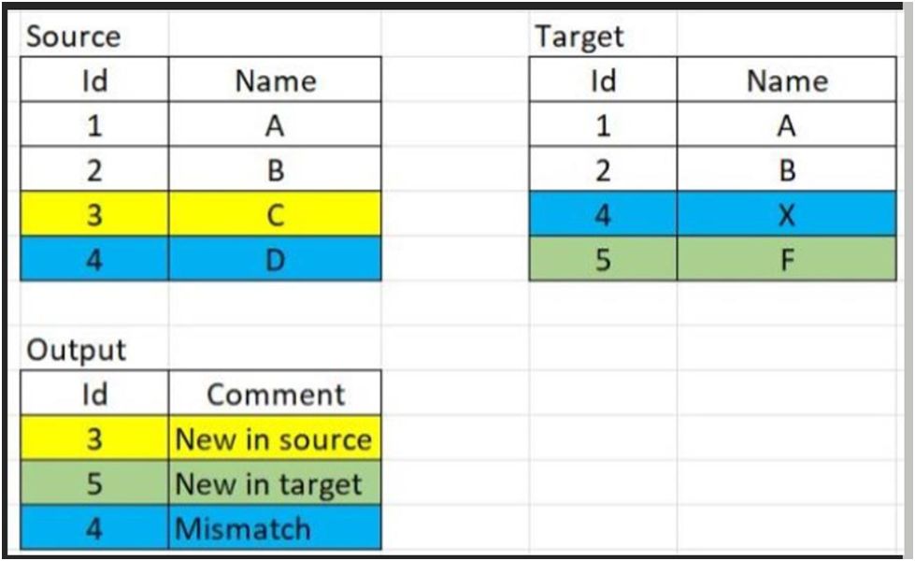

5) There are 10 IPL team. write a sql query such that each team play with every other team just once.
Also write another query such that each team plays with every other team twice.
Input:
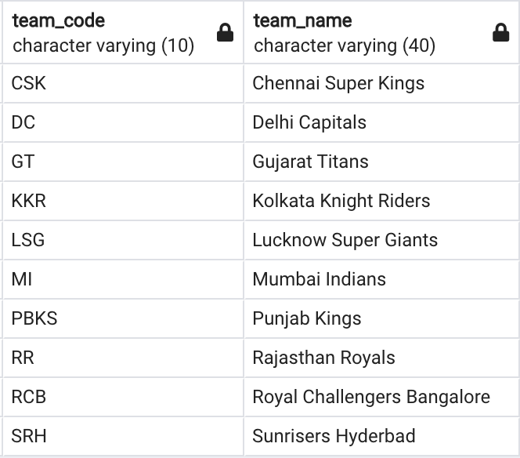
Output:
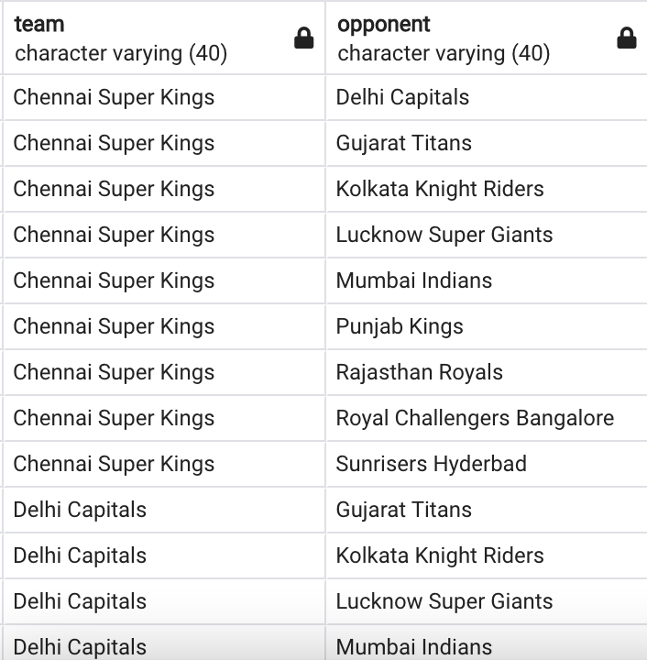And so on..

